EXP 3 : MATLAB SIMULATION OF SUPERHETERODYNE RECIEVER FOR AM COMMUNICATION SYSTEM WITH FREQUENCY MIXING AND FILTERING

SOFTWARE USED : MATLAB SOFTWARE

CODE :
clc;clear;close all
Fs=1e6;t=0:1/Fs:2e-3;
fm=5e3;fc=100e3;fi=20e3;flo=fc+fi;

m=cos(2*pi*fm*t);
AM=(1+.7*m).*cos(2*pi*fc*t); % AM signal
mix=AM.*cos(2*pi*flo*t); % Frequency mixing
[b,a]=butter(4,[fi-2*fm fi+2*fm]/(Fs/2));
IF=filter(b,a,mix); % IF filtering
out=IF.*2.*cos(2*pi*fi*t); % Demodulation
[b,a]=butter(4,2*fm/(Fs/2));
out=filter(b,a,out);

subplot(4,1,1),plot(t,m),title('Message'),grid on
subplot(4,1,2),plot(t,AM),title('AM Signal'),grid on
subplot(4,1,3),plot(t,IF),title('IF Signal'),grid on
subplot(4,1,4),plot(t,out),title('Recovered Signal'),grid on

MODEL GRAPH :
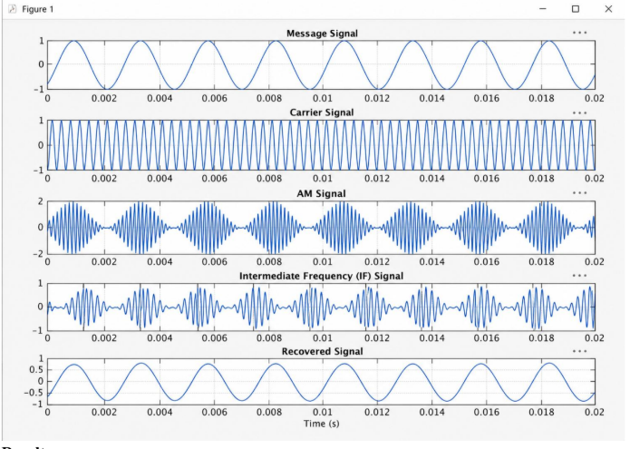

RESULT :
